Where: NH Beach Pizza

181 Merrimack Street
Haverhill, MA 01830
978-377-0056
When: Wednesday,
05/08/2019

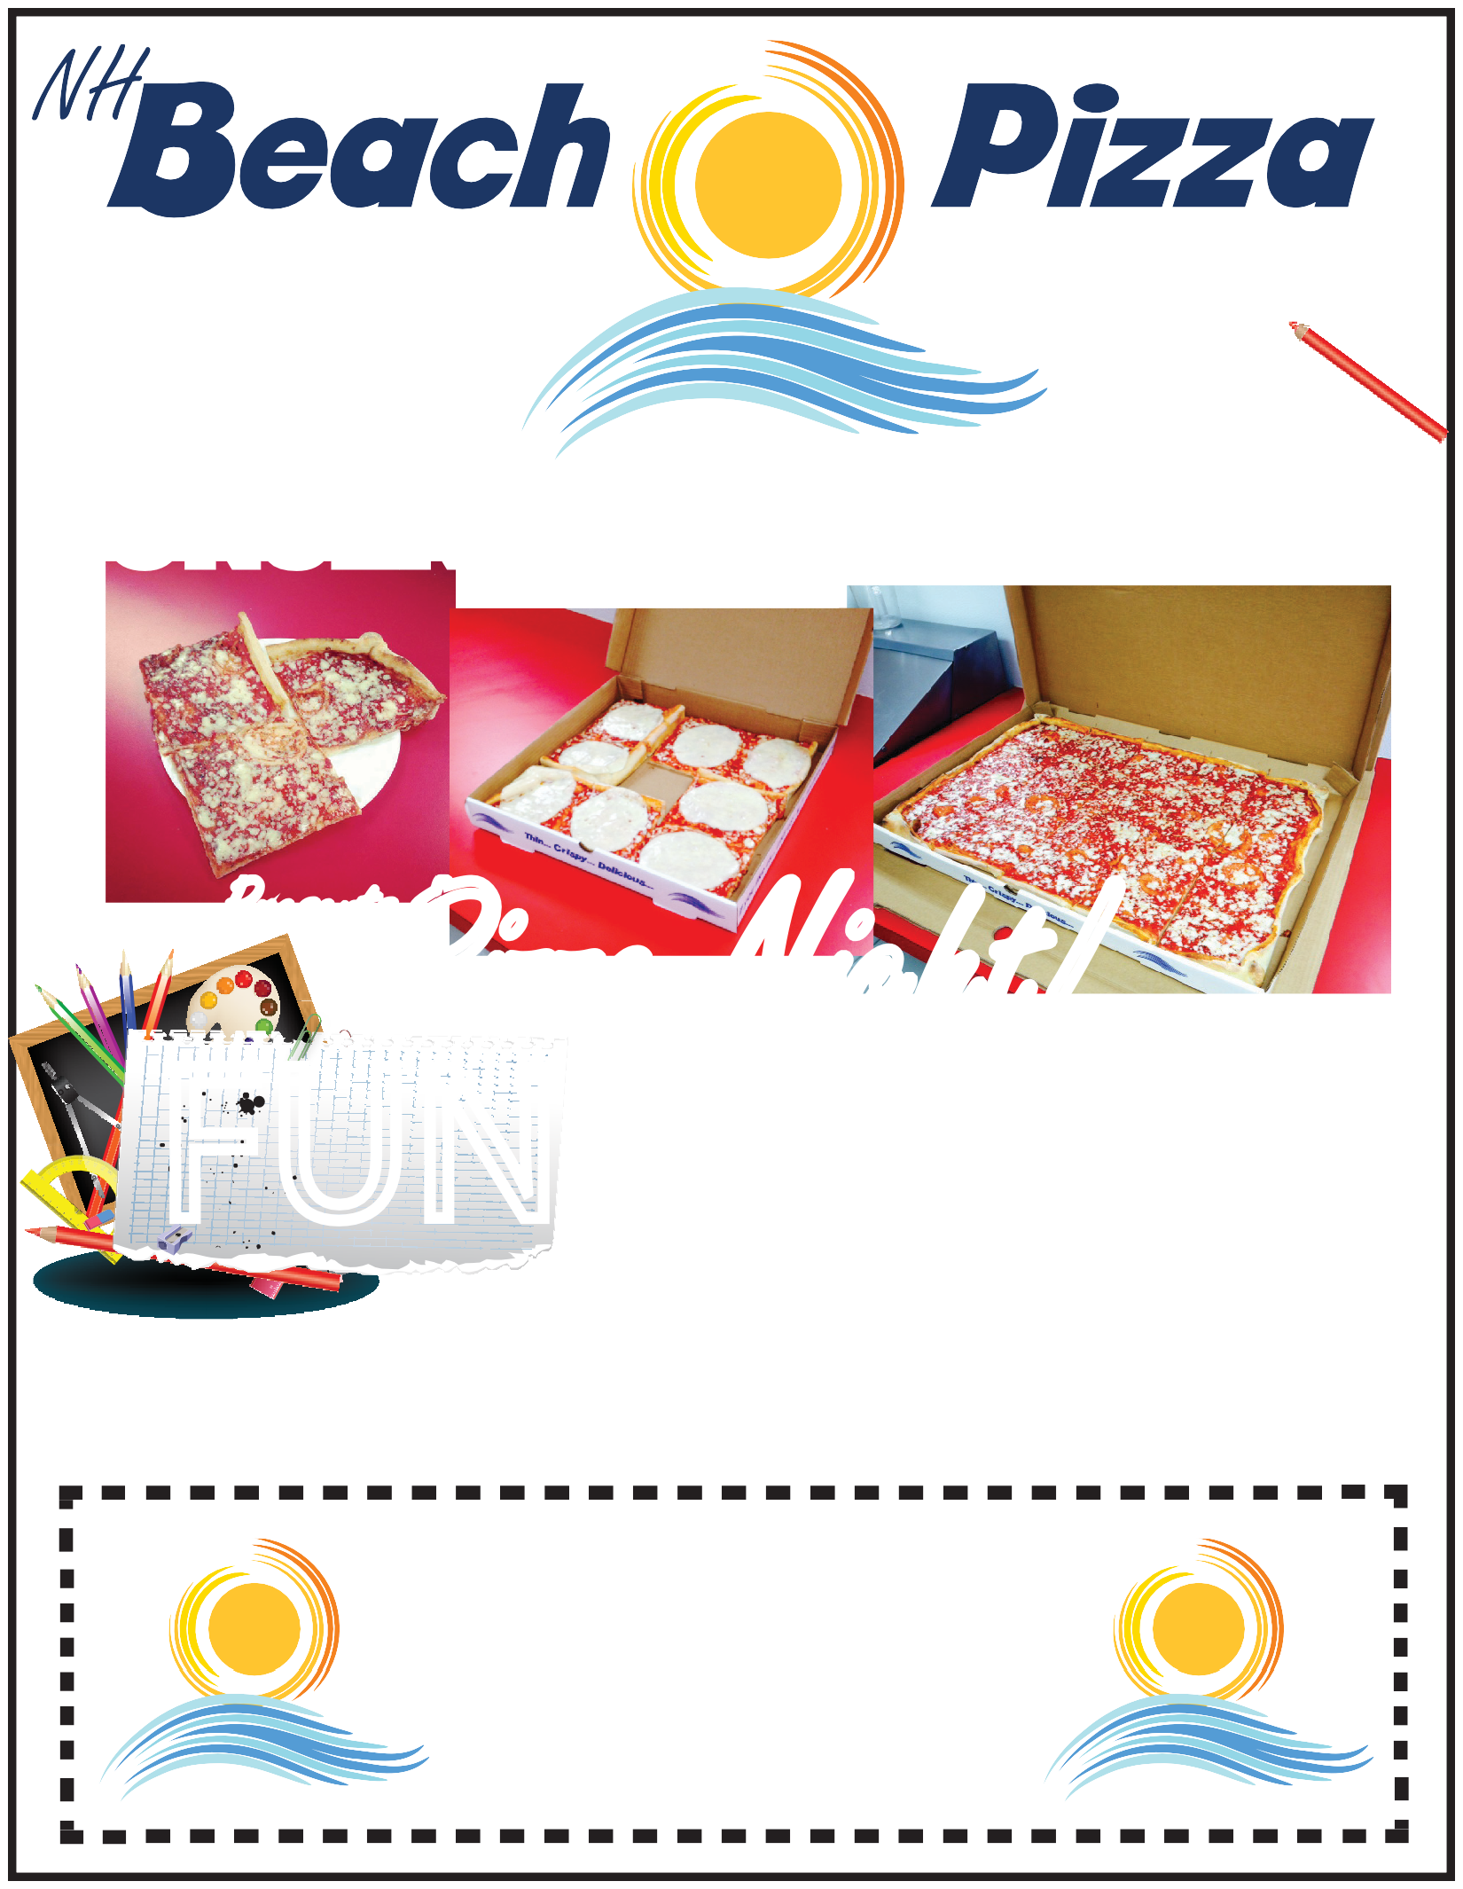
NETTLE School - PTO

Pizza Night!
Presents
FUNDRAISER
Name:
BRING IN THIS FLYER AND NH BEACH PIZZA WILL DONATE 20% OF YOUR PIZZA ORDER TO THE NETTLE SCHOOL - PTO.
Bring in this flyer on 05/08/2019 and 20% of your ordered will be donated to the Nettle School - PTO.
20%%%

Bring in this flyer on 05/08/2019 and 20% of your ordered will be donated to the Nettle School - PTO.
*excludes meals tax and cannot be combined with any other offers or coupons.

