Curbside Pickup
Curbside pickup is available as of 5/25.
Pickup is available Monday - Friday 10 am - 4 pm.
Limits per pickup: 5 adult items, 10 childrens items per order; only items in our building are available
You must have your library card number ready.
Currently you have two options:
- Place the hold(s) online. Call the library at 978-373-1586 to schedule a pickup. We need at least 2 hours to process your hold(s).
- Call the library at 978-373-1586 to place your hold(s) and schedule a pickup over the phone. We need at least 2 hours to process your hold(s).
Arrive at your scheduled time and park in a marked spot. Call us with your spot number and we will leave the books by your car! We will wave and smile (from behind our masks!)
Use the myLIBRO app to do it all from your smartphone: https://www.haverhillpl.org/blog/home/2020/06/curbside-pick-up-instructions/

Summer Reading
Imagine Your Summer 2020
Pre-register on June 1
Track reading and activities from June 15 - August 10
All tracking is done online at haverhillpl.beanstack.org
Or download the Beanstack app from Google Play or Apple App Store
**No internet at home? No problem! Schedule a time to come into the library to track your reading and activities or check out one of our laptops and/or hotspots to track at home.
Sign up the whole family for one of four challenges based on grade level
Tiny Heroes Club (Babies & Toddler - Preschool)
Fairy Tale Champions (K - 6)
Teen Reading Challenge (6-12) - sixth graders get to choose their challenge!
Adult Reading Challenge
Tiny Heroes Club
Read to your child for 20 minutes a day. Log six days over a two-week period and be entered into a prize drawing.
Complete activities that will help your little one identify shapes, learn the alphabet, and have fun! Activities earn you tickets into our Grand Prize drawings in which you could win $50 to Target or a local bookstore.
For every prize won we will donate the matching dollar amount to Sacred Hearts Food Pantry.
Summer Learning Challenge 2020 (K-6)
Read for 20 minutes a day. Reading together and listening to audiobooks counts!
For every day you read you earn 1 point.
Earn 20 points to win a free book! 30 points wins you a gift certificate for comics, ice cream, or pizza! Additional points earn bonus tickets into our Grand Prize drawing.
Grand Prizes include a Kindle Fire and a $100 Target Gift Card
For every prize won we will donate the matching dollar amount to Sacred Hearts Food Pantry.

Teen Reading Challenge (6-12th grade)
Earn points and badges by reading and completing various activities!
Every book and review you write earns you 1 point.
Activities earn 5-10 points.
Earning badges gets you raffle tickets for a Kindle Fire or Nintendo Switch Lite!
Earn 50 points to be entered into our gift card drawing. Gift cards include The Comic Book Palace, Target, and local pizza and ice cream places!(+)
Earn 200 points to complete the summer challenge (but keep going after you reach 200! See how many you can get!)
Adult Reading Challenge
Log every book you read
Read 8 books and be entered into our gift card drawing. Gift cards TBD

Teacher Card
All teachers are encouraged to call 978-373-1586 to receive a teacher card.
As of 5/19/2020 we are open Mon-Fri 9 a.m. - 5 p.m.

Family/Student Cards
English Online Application: https://www.haverhillpl.org/library-services/get-a-library-card/reg-form/
Spanish Online Application:
https://www.haverhillpl.org/library-services/get-a-library-card/reg-form-2/
Anyone without internet access is encouraged to call 978-373-1586 to apply for a card.
As of 5/19/2020 we are open Mon-Fri 9 a.m. - 5 p.m.

Search our Catalog
https://mvlc.ent.sirsi.net/client/en_US/haverhill/
Because we will not have Interlibrary Loan (ILL) service for the indeterminable future, we are limited to items only within our building.
Change “Everything” to Haverhill Public Library to view only the items in our catalog.
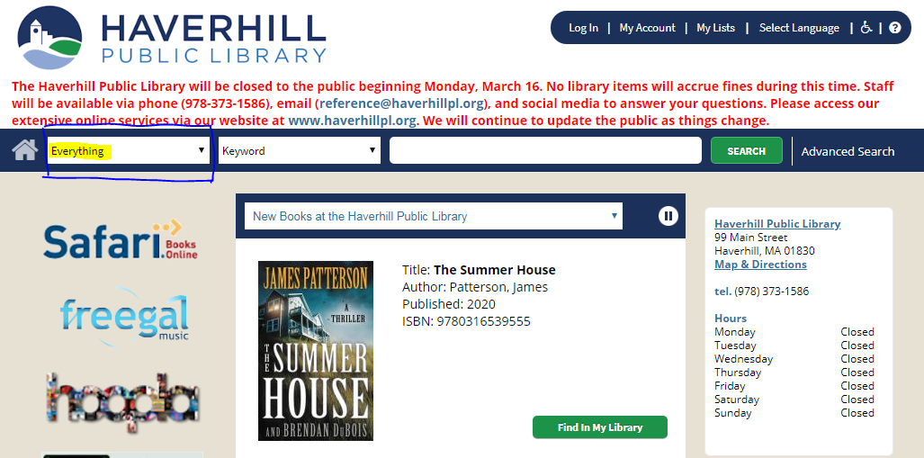

e-Books, Audiobooks, and Magazines Free w/Library Card
OverDrive: https://mvlc.overdrive.com/
OverDrive’s Libby App for Mobile Devices: https://www.overdrive.com/apps/libby/
Access all state digital collections by clicking on Partner Libraries.
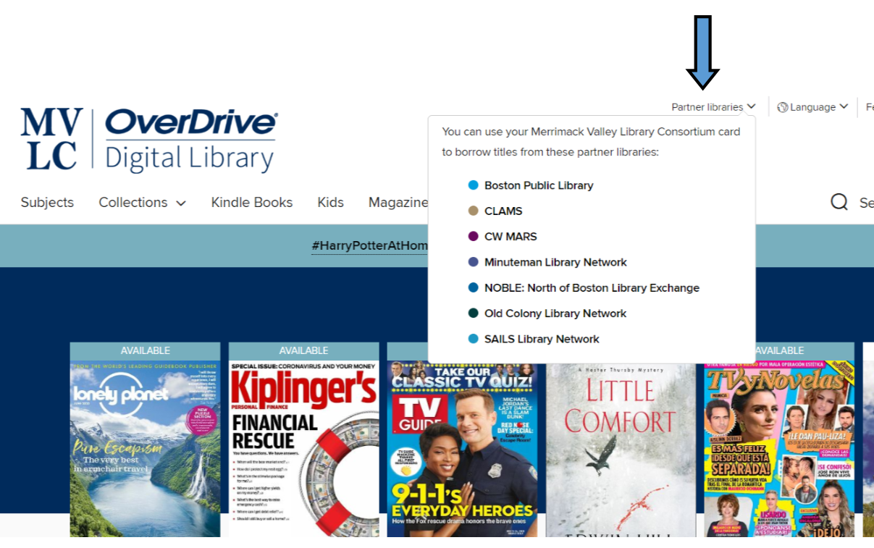

Other Resources Free w/ Library Card
Hoopla (ebooks, audiobooks, movies & more): https://www.hoopladigital.com/

Boston Public Library eCard
All Mass residents eligible to apply for a free card from Boston Public Library
http://bpl.org/ecard
Readers can then login to Hoopla and other digital resources with that card, resulting in additional monthly check outs
BPL has its own OverDrive:
https://bpl.overdrive.com/

