Nettle News
Nettle Middle School… Home of the Knights!
August 28th, 2022

Important Dates
Monday, August 29th
Open House for all grades 5:30pm-7:00pm
Tuesday, August 30st
First day of school!
Friday, September 2rd
Early dismissal at 11:05am
Monday and Tuesday, September 5th and 6th
No School
Thursday, September 22
School Wide Cookout, 4:00 - 5:30

Tuesday, September 19th
PTO Meeting 7pm-8pm

Student Schedules
Homerooms and schedules will be available on Schoolbrains starting August 26th.

PTO
Buy your mums from the PTO September Fundraiser this year!

Bus Routes
Look online at the Haverhill Public School’s website (Transportation Department) for bus routes . Bus passes will be distributed to students the first week of school. Students will be able to get on the bus without a bus pass as bus passes are being distributed.

Please note the walk zones by grade:
Grades K-3: If the student lives within 1 mile of the school they are a walker.
Grades 4-6: If the student lives within 1.5 miles of the school they are a walker.
Grades 7-12: If the student lives within 2 miles of the school they are a walker.
Exceptions to this rule are determined by the Superintendent.

Supplies
Student supplies will be provided as much as possible. If there are extra items, teachers will notify you the first week of school. Please provide your child with a water bottle. We are converting the traditional water fountains into water bottle fillers. IT WILL BE HOT the first week of school. Make sure you are sending your child to school with refillable water bottles.

Chromebooks
You have the opportunity to protect the Chromebook issued to your student for this school year by paying a Device Waiver Fee. This $20 fee will cover a single incident of damage or repair for the school year (not covering lost equipment) for your assigned device.
Please review the HPS Student Technology Device Policy.

If the annual optional Damage Waiver Fee is not purchased, the typical cost of repairing components is as follows, where an invoice could be send to the family:

- Charger - $39
- LCD Screen - $80
- Top Cover (keyboard, trackpad, etc.) - $139
- Device Replacement (when damage to the device is unrepairable) - $199
If you would like to submit your $20 (per student), please communicate with the office at 978-374-5792. Please make checks payable to: Haverhill Public Schools
Drop-off/Pick-Up
Student drop-off is 8:05am-8:25am at the back entrance. Students walk up the stairs to the field/playground until they are lined up for homeroom. Staff supervision begins at 8:05am, students can not be dropped off before 8:05. Pick up is 2:45pm-3:05pm at the same location as drop-off. Please do not line up early as it creates a traffic jam on Golden Hill Ave.
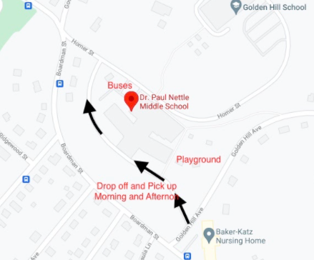Questions? Contact Eileen Doherty at Eileen.doherty@haverhill-ps.org

