Lekòl Piblik Haverhill

Akademi Vakans Avril 2024
An patenarya ak

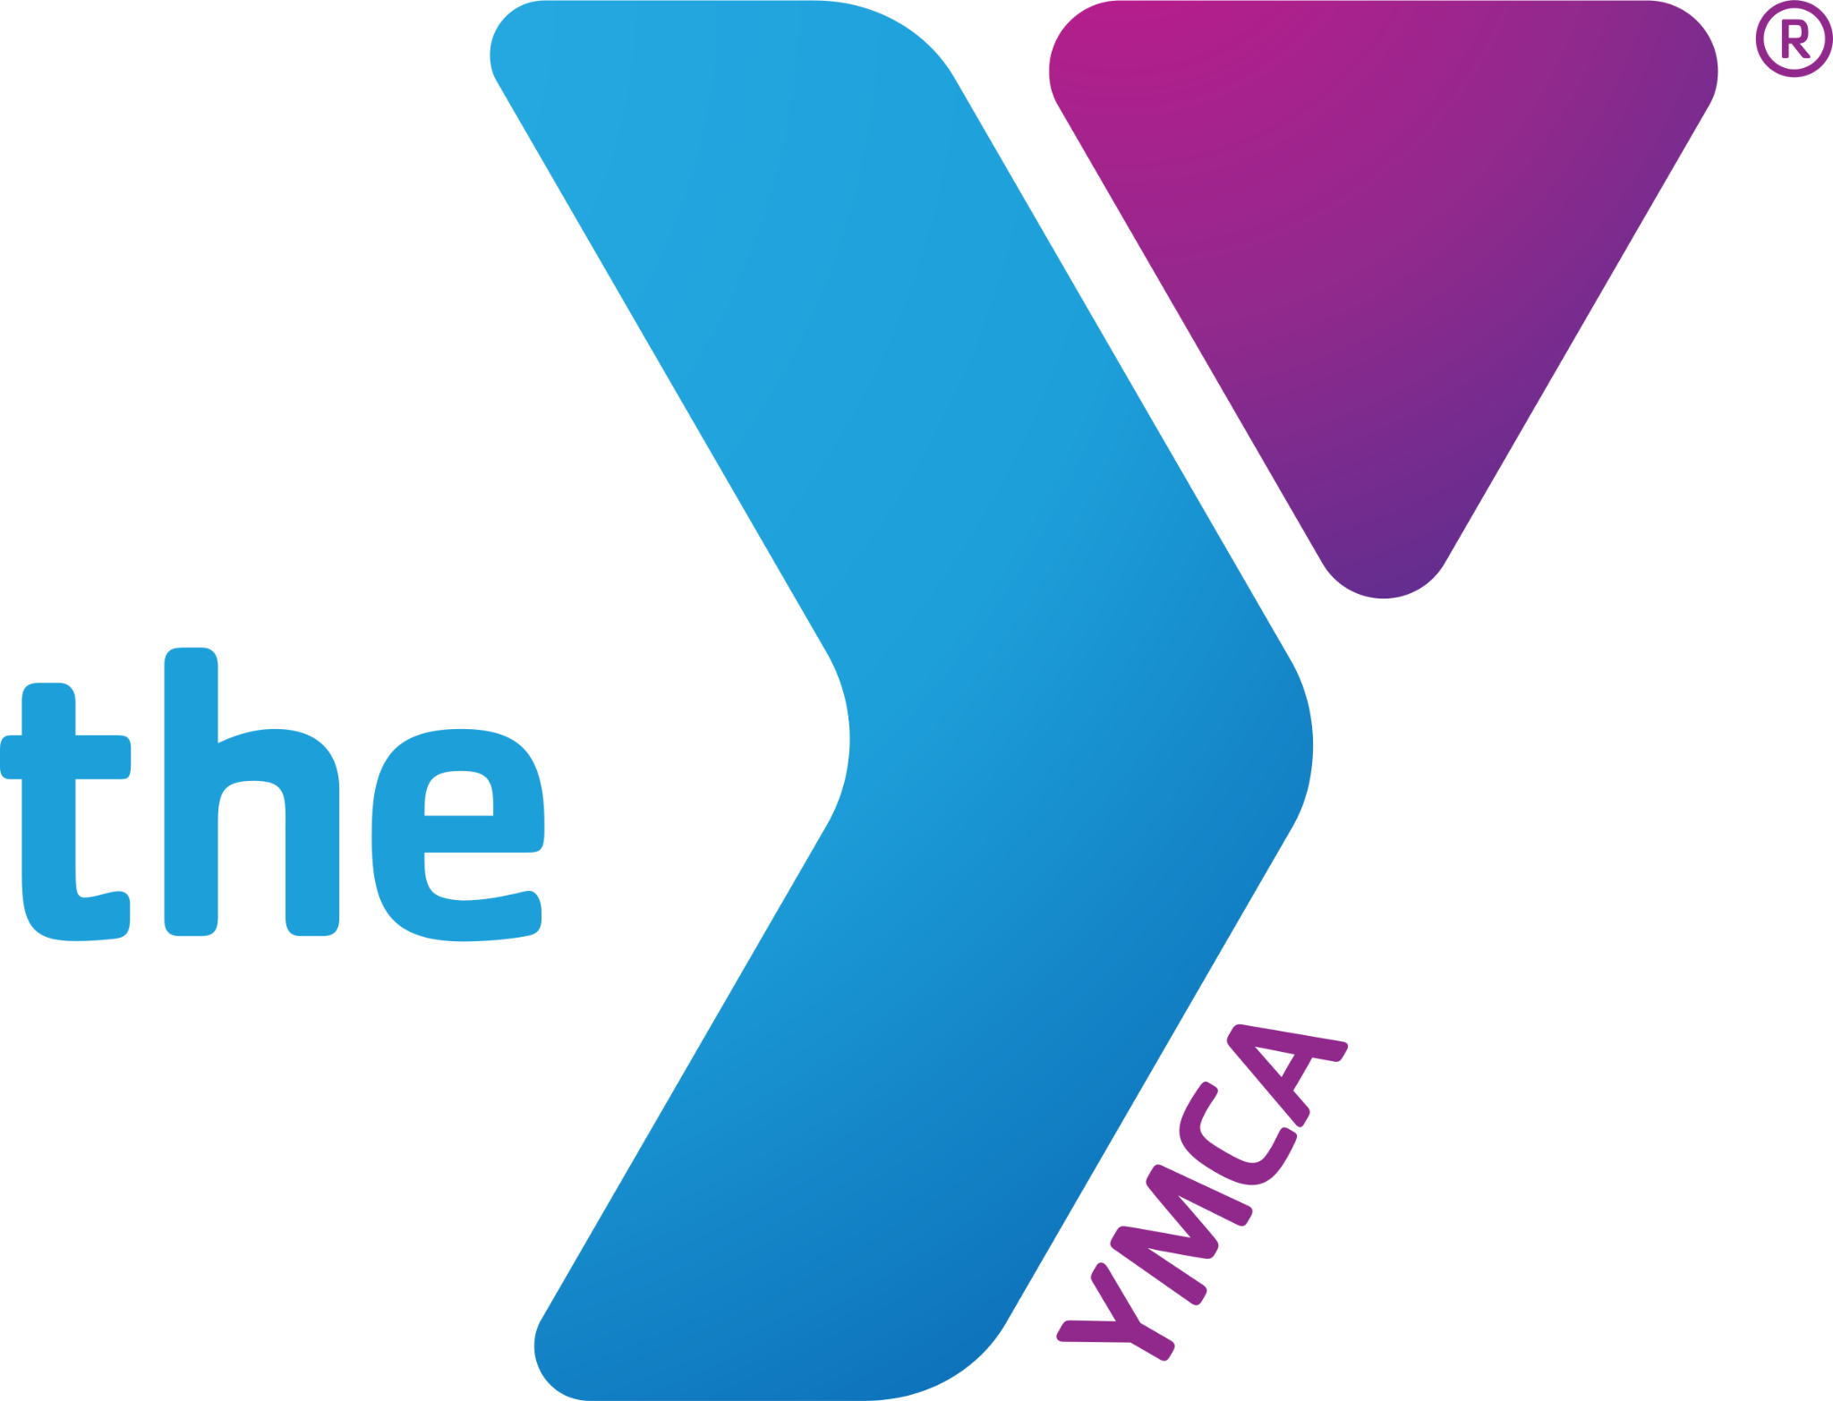
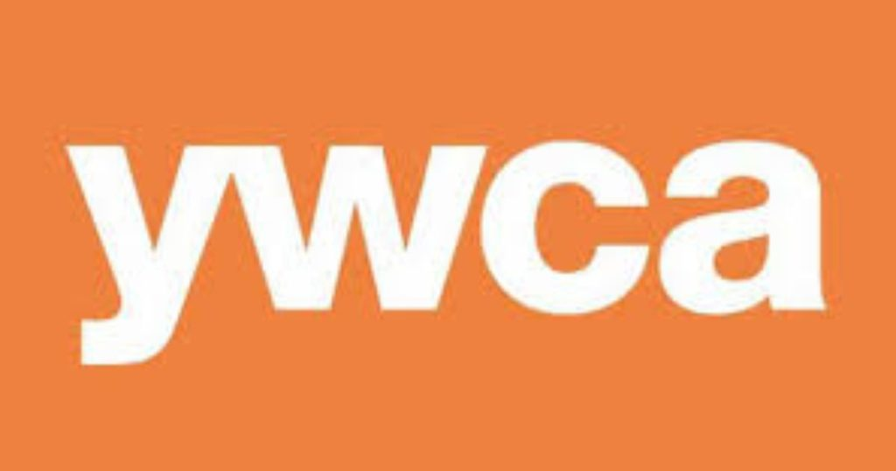
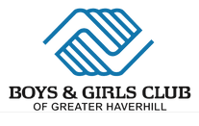

Kisa: Leson akademik ak aktivite lwazi pandan vakans avril pou kenbe elèv yo angaje
nan aprantisaj epi bay yon opsyon gadri bon jan kalite pou fanmi k ap travay yo gratis.

Ki Kote: Boys & Girls Club YMCA YWCA
55 Emerson Street 81 Winter Street & 107 Winter Street
Lilly Ruiz Pentucket Lake School Amy Desimone
frontdesk@haverhillbgc.org Cathy Wolf adesimone@ywcamema.org
(978) 374-6171 ext. 100 wolfc@northshoreymca.org (978) 374-6121 (978) 374-0506

Ki lè: Madi 16 Avril - Vandredi 19 Avril 2024

Orè: 8:30 am - 5:30 pm (YMCA fèmen a 6:00 pm)
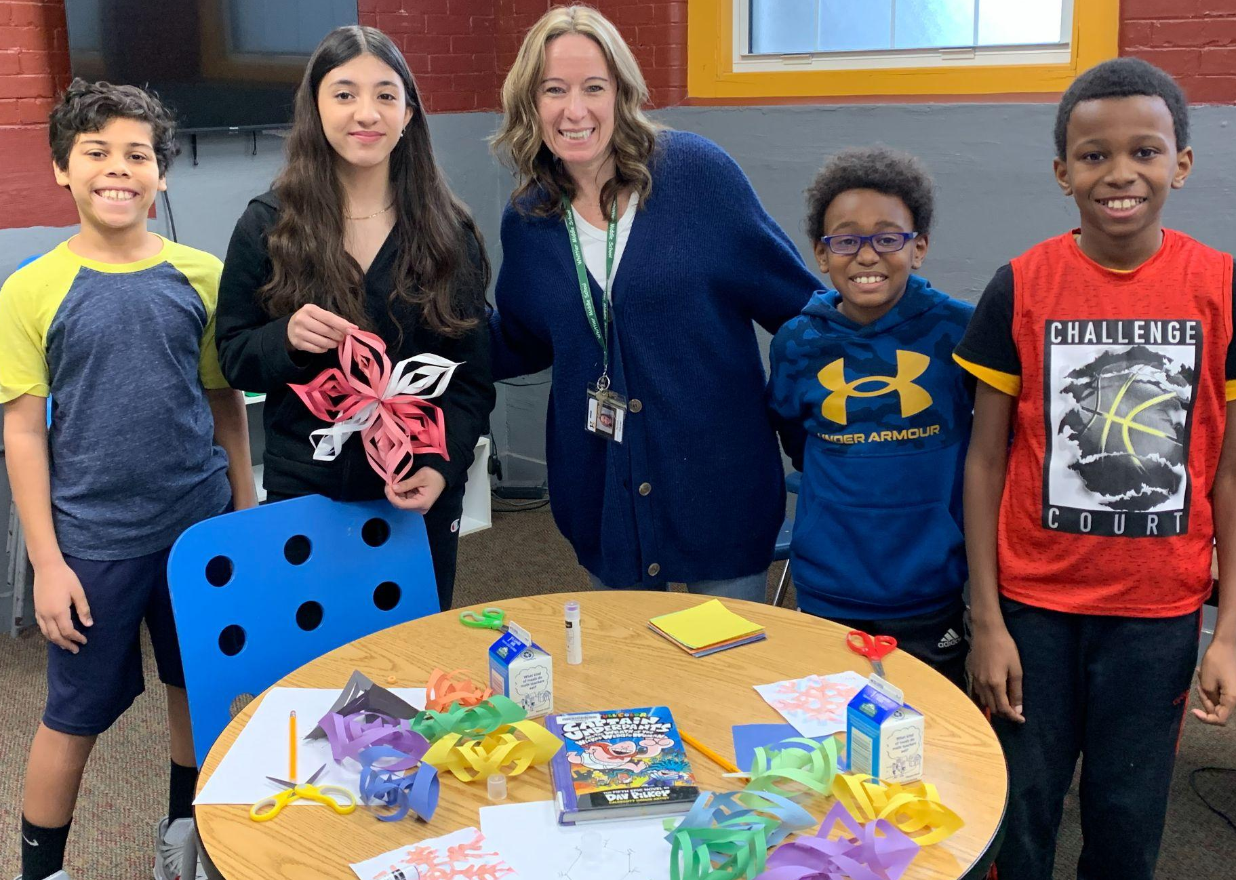
Akademik: 8:30 am - 12:30 pm
Manje Midi: 12:30 pm - 1:00 pm
Rekreyasyon: 1:00 pm - 5:30 pm

Kiyès: Elèv HPS nan Klas K-8

Ki jan: Èske mwen dwe anrejistre pitit mwen an?
Rele kote pwogram ou chwazi a (gade pi wo a).

Nòt: Elèv yo dwe enskri nan yon lekòl piblik Haverhill men yo pa bezwen manm òganizasyon an pou yo ale!

